**Australia Completes Extradition of Alleged High-Ranking Triad Who Washed Drug Money at Crown**

Posted on: June 13, 2022, 07:49h.

Last updated on: June 14, 2022, 06:43h.

Avatar photo

[Philip Conneller](https://www.casino.org/news/author/phillip-conneller/)[@casinoorgphilc](https://twitter.com/casinoorgphilc)

Expertise: [Gaming Business](https://www.casino.org/news/gaming-business/), [Regulation](https://www.casino.org/news/regulation/), [Tribal Gaming](https://www.casino.org/news/tribal-gaming/).

An alleged international narcotics smuggler whose organization was accused of washing millions through the Crown Melbourne Casino’s VIP rooms has been extradited to Australia from Thailand.

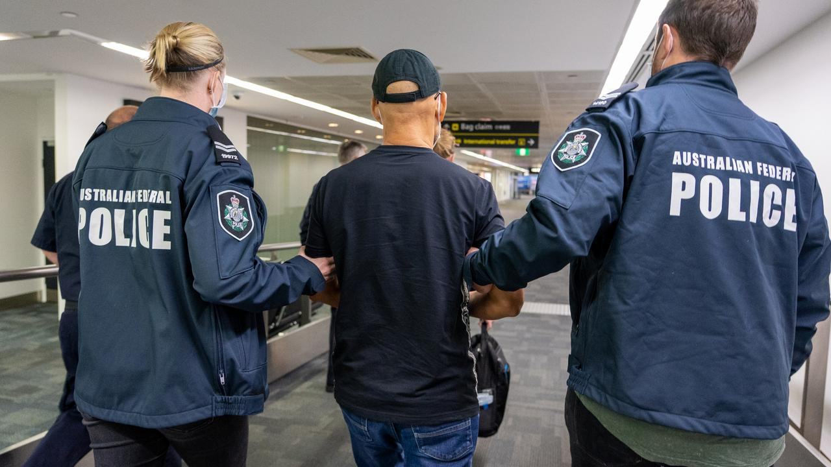Lee Chung Chak is led handcuffed through Melbourne Airport Saturday by AFP officers after arriving on a flight from Bangkok. (Image: *The Australian*)

[**Lee Chung Chak**](https://www.casino.org/news/triad-who-laundered-drug-money-through-crown-melbourne-arrested/), 66, is reputed to be second in command of “the Company,” also known as Sam Gor, a super-syndicate formed by an alliance of previously warring triad factions.

**The organization is one of the biggest narcotics trafficking operations in the world. It is believed to be responsible for up to 70% of illegal drugs smuggled into Australia over the past 20 years.**

British-Chinese national Lee was arrested in Bangkok in October 2020 after charges were laid in Australia. He had been fighting extradition, claiming a case of mistaken identity.

**Crown Melbourne Operations**

Australian authorities allege he is the right-hand man of [**Tse Chi Lop**](https://www.casino.org/news/tse-chi-lop-boss-of-triad-super-syndicate-the-company-arrested/), dubbed “Asia’s El Chapo,” and the reputed leader of the Company. Tse was arrested in Amsterdam in January 2021.

The two men were imprisoned in the US in the 1980s after being convicted on heroin trafficking charges.

**Lee allegedly operated a junket business partnered with Crown Melbourne in 2012 and used the casino’s VIP services to launder millions.**

In 2013, Whye Wah Moo, or Roy Moo, was sentenced to two years in prison for money laundering. The Bergin report in New South Wales into whether Crown was fit to hold a license for the Crown Sydney linked Moo to the Company in no uncertain terms.

There is no doubt that the money laundered by Roy Moo came from the proceeds of criminal activity by the international drug trafficking syndicate, The Company,” the Bergin inquiry’s report stated. “There is no doubt that the money was laundered through Crown Melbourne.”

The Company was also linked to the seizure of $1 billion worth of methamphetamine in Western Australia in 2017.

**Designer Gear and Handcuffs**

Australian prosecutors claim Lee conspired to traffic 40kg of methamphetamine into Australia over 12 months in 2012.

The alleged drug kingpin arrived in Melbourne on Saturday wearing a black Armani shirt, Balenciaga sunglasses, and handcuffs. He appeared at Melbourne magistrates court later in the day to be formally charged with conspiracy to traffic a commercial quantity of a controlled drug.

The maximum penalty for this offense is life imprisonment.

“This is a significant milestone after years of persistent investigative work by the AFP and our partners,” Krissy Barrett, Australian Federal Police Assistant Commissioner for Southern Command, told *The Daily Telegraph.*